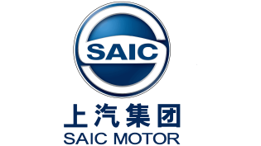

SAIC Motors Corporation Limited


GSO Conformity Certificate CCR No. 578921
Motor Vehicles
Manufacturer: SAIC MOTOR CORPORATION LIMITED
Country of Origin: CHINA, Country of Production: CHINA
To: GCC Standardization Organization (GSO)
We hereby certify that the vehicles manufactured by SAIC MOTOR CORPORATION LIMITED
* Type: MG 6 XLINE Trophy 1.5T Sedan FWD 4 Doors
* VlN number: LSJW54U9*S*******
* Model Year: 2025 * Produced in and after: Month 04 Year 2025
* Category: Passenger Car
Will satisfy the G50 Technical Regulations Nos: 34:20o7, 3s:2007, 36:2005, 37:2012, 38:200s, 392005, 40:2011,42:2015, 48:1984, 51:20o7, 52:2007, 53.2007, 9611988. 9721988, 9811988, 9921988,13522007, 13622007. 29021994. 4119:1994,42o:1994,421:2005,422:200s.1040:20001041:2000,1042:2000,1053:2000,1503:2010,1598:2002,1624:2002,1677:2003,1708:2o0s,1780:2010,1781:2006,1782:2008,1783:2006,1784:2o0e.Gsolso1585:2008,GSO lSO 3537:2008, GSO 150 3538:1997, G50 ECE13H:2012,GSO ECE13H-1:2012,GSO ECE13H-2:2012,GSO ECE 13H-3:2012, GSO ECE13H-4:20l2, GSO ECE13H-S:2012,GSO ECE 13H-6:2012 and the standards in the country of origin accepted by GSO in the case that no GSO technical regulations and standards are available.
All the essential technical data are as follows:
1. Weights
a. Maximum Vehicle Weight: 1811 kg b. Curb: 1320 kg
c. Maximum Axle Weight: Front: 950 kg Rear: 900 kg
2. Dimensions
a. Length: 4738 mm b. Width: 1848 mm
c. Height: 1456 mm d. Wheelbase (Fl R1) 2715 mm e. Track: Front: 1580 mm Rear: 1580 mm
3. Type of chassis and body: Monocoque
4. Number of Passengers: 5(Including the Driver)
5.Engine: Petrol a. Cylinders: 4 b. Displacement: 1490cc c. Air intake: Turbo
d. Net Engine Power: 133 kW at 5600 rpm Pollutant Limit comply with Euro 6.
6. Transmission: DCT
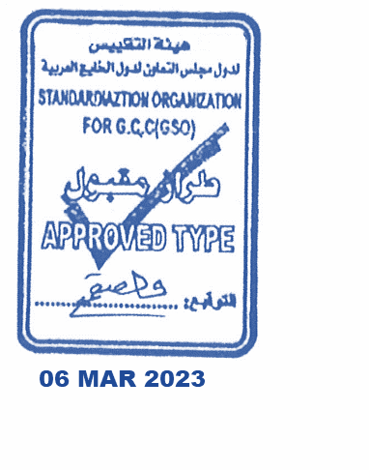
7. Brakes a. Service Brakes: Hydraulic b. Emergency Brakes: Combined with the service brake
8. Fuel Economy a. Motor Vehicle Class: Passenger Car b. FE (CAFE) Combined: 16.2 km/L - Good
9. Any other information or local standards to be compiled: Also comply with the National regulations for member countries mentioned in the Annex of the list of Technical Regulations for MV 2025 MY-D5, when exporting to those countries.

11 OCT 2025 20220202520252025

